Report
Credit Risk

Personal Data Analysis Project
Dataset: Credit Risk Dataset (Kaggle)
Name: Doan Nguyen My Ngan
September, 2026

Table of Contents
1. Dataset 4
1a) Purpose of the report & Summary of the dataset 4
1b) Loading dataset 4
1c) First few rows of the Dataset 4
1d) Data Attributes 5
2. Data Pre-processing 5
2a) Handling Duplicates 5
2b) Handling Outliers 6
2c) Target Variable Balance 7
3. Explore and Visualize the Clean Dataset 7
3a) Summary Statistics 7
3b) Numerical Distribution Charts 8
3c) Distribution of Categorical Attributes 9
4. Multivariate Analysis 10
4a) Correlation Analysis 10
4b) Two Categorical Variables vs Count 10
4c) Aggregation Analysis (Mean & Median) 11
4d) How Loan-to-Income Ratio Affects Default Rate 12
5. Conclusion 13
5a. Key Findings 13
5b. Challenges Encountered 14
5c. Suggested Next Steps 14
6. Modeling 15
6a. Baseline Model — Logistic Regression 15
6c. Model Comparison 16
7. Final Conclusion & Business Recommendations 17

List of Figures and Tables
Table 1: First 5 Rows of the Dataset
Table 2: Overview for All Attributes
Table 3: Rows identified with logically impossible age or employment length values.
Figure 1: Boxplots of person_age and person_emp_length prior to cleaning.
Table 4: Row count and maximum values before and after outlier treatment.
Table 5: Target Variable Balance
Table 6: Summary statistics of key numerical attributes
Figure 2: Distribution of key numerical attributes
Figure 3: Distribution of key categorical attributes.
Figure 4: Correlation heatmap of numerical attributes.
Table 7: Borrower counts by loan grade and prior default history.
Figure 5: Count of borrowers by loan grade and prior default history.
Table 8: Mean and median interest rate by home ownership status.
Figure 6: Mean and median interest rate by home ownership status.
Table 9: Mean default rate and variation by loan-to-income ratio bin.
Figure 7: Default rate by loan-to-income ratio bin, with variation.
Table 10: Classification report — baseline logistic regression.
Figure 8: Matrix of baseline logistic regression.
Table 11: Classification report — balanced logistic regression.
Figure 9: Matrix of balanced logistic regression
Table 12: Comparison of baseline and balanced logistic regression models.

1. Dataset

1a) Purpose of the report & Summary of the dataset
This report presents a data analysis of Credit Risk patterns. The purpose is to investigate the relationship between loan default and borrower characteristic, guided by the 5C framework. The analysis follows a structured EDA pipeline: data loading, cleaning, descriptive statistics, visualization, multivariate analysis, which uncover patterns that could inform how borrower characteristics relate to loan default. This useful data can provide for:
- Banks and lending firms can use this type of analysis to predict risk and make more informed decisions about which borrowers to approve, reducing the risk of bad loans.
- By making more reliable lending decisions, banks can strengthen their reputation and build greater trust with customers.
Summary: The Credit Risk Dataset is a large-scale, synthetically generated dataset designed to model relationships between personal information, customer history with their employment status among individuals aged 20-94. This dataset stimulates realistic correlations between personal age, income, employment information indicators using controlled statistical generation techniques. The dataset contains 32,581 respondent records across 12 attributes, covering three broad groups: (1) Demographics: Age, Annual Income, Home Ownership and Employment Length; (2) Loan information: Loan Intent, Loan Grade, Loan Amount, Interest Rate, Loan Status and Percent Income; (3) Credit Historical Information: Historical Default and Credit History Length.

1b) Loading dataset
The dataset was loaded into DataFrame using the pandas library. Additional libraries used later in this analysis include numpy for numerical operations, and matplotlib and seaborn for visualization. The first rows confirm 12 columns, a mix of numeric and text data, one row per borrower, with no issues on initial inspection.

1c) First few rows of the Dataset
The table below shows this output, transposed (attributes as rows and records as columns) so it its on page given the dataset has 12 columns:
Attributes | Row 0 | Row 1 | Row 2 | Row 3 | Row 4
person_age | 22 | 21 | 25 | 23 | 24
person_income | 59000 | 9600 | 9600 | 65500 | 54400
person_home_ownership | Rent | Own | Mortgage | Rent | Rent
person_emp_length | 123.0 | 5.0 | 1.0 | 4.0 | 8.0
loan_intent | Personal | Education | Medical | Medical | Medical
loan_grade | D | B | C | C | C
loan_amnt | 35000 | 1000 | 5500 | 35000 | 35000
loan_int_rate | 16.02 | 11.14 | 12.87 | 15.23 | 14.27
loan_status | 1 | 0 | 1 | 1 | 1
loan_percent_income | 0.59 | 0.1 | 0.57 | 0.53 | 0.55
cb_person_default_on_file | Y | N | N | N | Y
cb_person_cred_hist_length | 3 | 2 | 3 | 2 | 4
Table 1: First 5 Rows of the Dataset

1d) Data Attributes
Data Type | Count | Attributes
Integer (int64) | 5 | person_age, person_income, loan_amnt, loan_status, cb_person_cred_hist_length
Float (float64) | 3 | person_emp_length, loan_int_rate, loan_percent_income
Object/String (str) | 4 | person_home_ownership, loan_intent, loan_grade, cb_person_cred_hist_length
Table 2: Overview for All Attributes
The DataFrame has 32,581 rows and 12 columns. These are 8 numerical attributes ( 5 integer: Age, Annual Income, Loan Amount, Loan Status and Credit Risk History Length and 3 floating point: Employment Length, Interest Rate and Percent Income) and 4 categorical attributes: Home Ownership, Loan Intent, Loan Grade and Historical Default.

2. Data Pre-processing

2a) Handling Duplicates
A check for duplicated rows found 165 duplicated rows in the dataset, therefore, the appropriate action would have been to remove them, since repeated survey responses would inflate their influence on summary statistics and correlations. The new dataset which has been eliminated by 165 duplicated rows remains 32416 rows and 12 attributes.

2b) Handling Outliers
Numerical attributes were reviewed for implausible values in addition to standard statistical outlier checks, reviewing minimum and maximum values and inspecting the most extreme individual rows.
Two attributes were found to contain logically impossible values: person_age contained values of 144 and 123, and person_emp_length contained a value of 123 for individuals aged 21–22, impossible, since employment length cannot exceed age. A check confirmed no overlap between the two affected row sets. In total, 7 rows were impacted, summarized in Table 3.
Row | person_age | person_emp_length | Issue
81 | 144 | 4.0 | Age impossible
183 | 144 | 4.0 | Age impossible
32297 | 144 | 12.0 | Age impossible
575 | 123 | 2.0 | Age impossible
747 | 123 | 7.0 | Age impossible
0 | 22 | 123.0 | Employment length exceeds age
210 | 21 | 123.0 | Employment length exceeds age
Table 3: Rows identified with logically impossible age or employment length values.
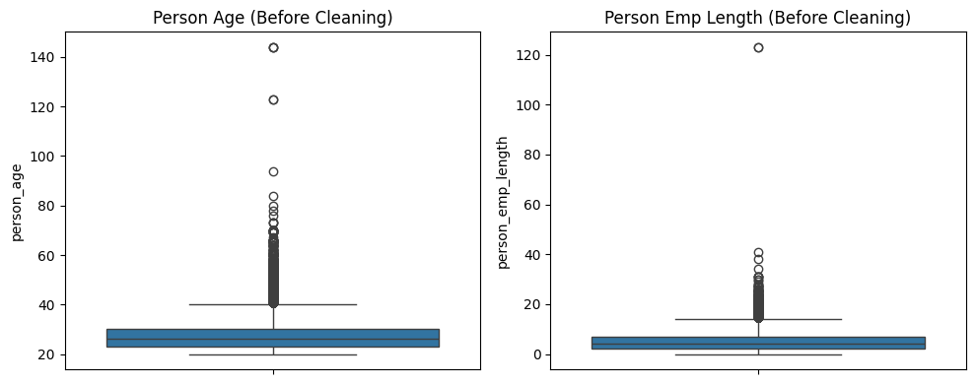Figure 1: Boxplots of person_age and person_emp_length prior to cleaning.
Rather than applying a generic statistical rule, a domain-based logical threshold was used: rows where person_age > 100 or person_emp_length > 60 were removed. This targets values that are impossible in reality, rather than values that are merely statistically unusual.
In contrast, person_income contained high values up to 2,039,784, but was not treated as an outlier. Sorting the data by income showed a gradual decline in frequency (51 rows above 500,000, 8 above 1,000,000) rather than a sharp cutoff, consistent with a right-skewed distribution typical of income data, rather than a data entry error. These values were retained, with the skew to be addressed later during Feature Engineering via a log transformation.
After cleaning, the dataset was reduced from 32,581 to 32,409 rows in total (duplicates and outliers combined), as summarized in Table 4.

Metric | Before | After
Total Rows | 32,581 | 32,409
Max person_age | 144 | 94
Max person_emp_length | 123 | 41
Table 4: Row count and maximum values before and after outlier treatment.

2c) Target Variable Balance
The target variable, loan_status, shows a class imbalance: 78.13% of borrowers did not default, while 21.87% defaulted. This imbalance is an important consideration for later model evaluation, since accuracy alone would be a misleading metric
loan_status | proportion
0 | 78.13%
1 | 21.87%
Table 5: Target Variable Balance

3. Explore and Visualize the Clean Dataset

3a) Summary Statistics
 | Mean | Median | Standard deviation | Min | Max
person_age | 27.73 | 26.00 | 6.21 | 20.00 | 94.00
person_income | 65,894.28 | 55,000.00 | 52,517.87 | 4,000.00 | 2,039,784.00
person_emp_length | 4.95 | 4.00 | 4.11 | 0.00 | 41.00
loan_amnt | 9,592.49 | 8,000.00 | 6,320.89 | 500.00 | 35,000.00
loan_int_rate | 11.02 | 11.01 | 3.08 | 5.42 | 23.22
loan_percent_income | 0.17 | 0.15 | 0.11 | 0.00 | 0.83
cb_person_cred_hist_length | 5.81 | 4.00 | 4.06 | 2.00 | 30.00
Table 6: Summary statistics of key numerical attributes
The gap between mean and median for person_income (65,894 vs 55,000) and loan_amnt (9,592 vs 8,000) indicates right-skewed distributions, consistent with the presence of a small number of very high earners and larger loan amounts.

3b) Numerical Distribution Charts
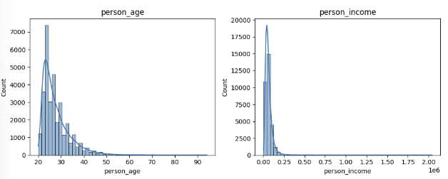
Figure 2: Distribution of key numerical attributes
While person_age is more tightly clustered, person_income and loan_amnt show a pronounced right skew. Additional histograms for person_emp_length and loan_percent_income are provided in the Appendix and show a similar high in the beginning and curve at the end.

3c) Distribution of Categorical Attributes
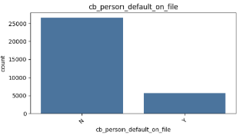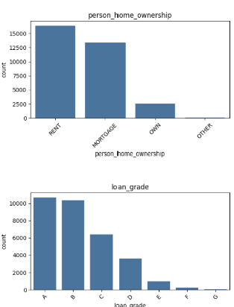
Figure 3: Distribution of key categorical attributes.
Loan grades A and B dominate the sample, while grade G is rare; RENT and MORTGAGE are the most common home ownership categories. Regarding the person_default_on_file, people with No far out weigh those who have a Yes.

4. Multivariate Analysis

4a) Correlation Analysis
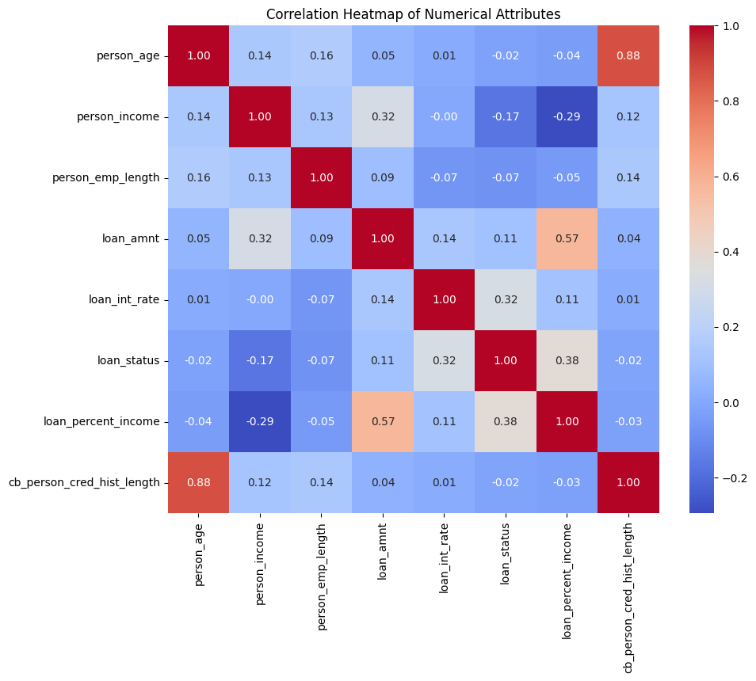
Figure 4: Correlation heatmap of numerical attributes.
Among all numerical attributes, loan_percent_income shows the strongest correlation with loan_status (0.38), followed by loan_int_rate (0.32) and person_income (-0.17). This is consistent with the '5C Capacity' framework: the proportion of income committed to loan repayment is the single strongest numerical indicator of default risk in this dataset.
A notable correlation of 0.88 was also found between person_age and cb_person_cred_hist_length, reflecting that credit history accumulates with age. This multicollinearity will be considered during Feature Engineering.

4b) Two Categorical Variables vs Count
Borrower counts were examined across loan_grade and cb_person_default_on_file (prior default history), corresponding to the 'Character' dimension of the 5C framework.
Loan Grade | Prior Default (Y/N) | Count
A | N | 10,702
B | N | 10,384
C | N | 3,191
C | Y | 3,245
D | N | 1,747
D | Y | 1,872
E | N | 499
E | Y | 464
F | N | 129
F | Y | 112
G | N | 28
G | Y | 36
Table 7: Borrower counts by loan grade and prior default history.
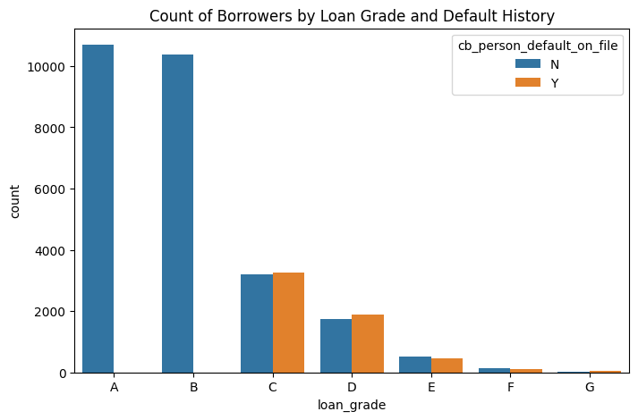
Figure 5: Count of borrowers by loan grade and prior default history.
Lower loan grades (E, F, G) show a much higher proportion of borrowers with a prior default on file compared to higher grades (A, B), indicating that loan grade is closely tied to credit history.

4c) Aggregation Analysis (Mean & Median)
Interest rate (loan_int_rate) was aggregated by home ownership status (person_home_ownership), corresponding to the 'Collateral' dimension of the 5C framework. This pairing was chosen because home ownership status often reflects the collateral or financial stability a borrower can offer, which lenders may factor into pricing.

Home Ownership | Mean Interest Rate | Median Interest Rate | Std Dev
MORTGAGE | 10.55 | 10.99 | 3.14
OTHER | 11.90 | 11.58 | 2.49
OWN | 10.88 | 11.01 | 3.11
RENT | 11.42 | 11.01 | 2.98
Table 8: Mean and median interest rate by home ownership status.
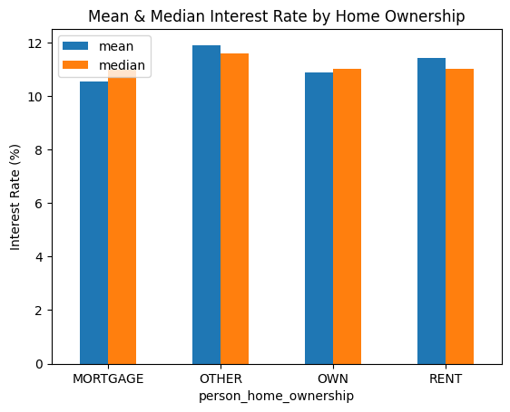
Figure 6: Mean and median interest rate by home ownership status.
Borrowers renting or in the 'Other' category are charged slightly higher average interest rates than those with a mortgage or who own their home outright, consistent with home ownership acting as a proxy for financial stability.

4d) How Loan-to-Income Ratio Affects Default Rate
The relationship between loan_percent_income (binned) and default rate was examined, corresponding to the 'Capacity' dimension of the 5C framework, with variation shown via standard deviation.
Loan % of Income (Bin) | Mean Default Rate | Std Dev
[0.0, 0.1) | 0.116 | 0.320
[0.1, 0.2) | 0.147 | 0.355
[0.2, 0.3) | 0.210 | 0.407
[0.3, 0.4) | 0.619 | 0.486
[0.4, 0.5) | 0.725 | 0.447
[0.5, 0.6) | 0.774 | 0.419
[0.6, 0.7) | 0.729 | 0.449
[0.7, 0.8) | 0.818 | 0.405
Table 9: Mean default rate and variation by loan-to-income ratio bin.
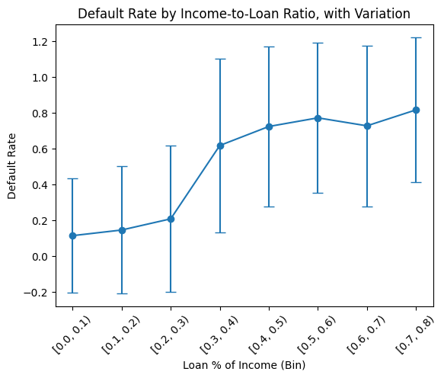
Figure 7: Default rate by loan-to-income ratio bin, with variation.
Default rate rises sharply once a loan exceeds roughly 30% of a borrower's income, climbing from around 12-21% in the lowest bins to over 70% in bins above 0.4. This confirms loan_percent_income as the most powerful single risk indicator identified in this analysis, consistent with its position as the strongest correlate of loan_status in the correlation heatmap.

5. Conclusion

5a. Key Findings
- The dataset required moderate cleaning: 165 duplicate rows and 7 rows with logically impossible values (age > 100, employment length exceeding age) were removed, reducing the dataset from 32,581 to 32,409 rows.
- High person_income values were identified as a natural right-skewed tail rather than data errors, and were retained rather than removed.
- The target variable is imbalanced: 78.1% no-default vs 21.9% default.
- A strong correlation was found between person_age and cb_person_cred_hist_length, indicating multicollinearity to be addressed during feature engineering.
- loan_percent_income is the strongest single correlate of default risk, supporting the 'Capacity' dimension of the 5C framework.
- Lower loan grades (E-G) are strongly associated with a prior default on file, supporting the 'Character' dimension.
- Home ownership status is associated with modest differences in interest rate, consistent with its role as a proxy for financial stability ('Collateral').

5b. Challenges Encountered
- Distinguishing between logically impossible outliers (age, employment length) and legitimate but unusual values (high income) required careful, variable-specific judgment rather than a single uniform rule.
- Ensuring consistency of the cleaned dataframe across all subsequent analysis steps required careful tracking, as several early calculations were inadvertently performed on the uncleaned data before being corrected.

5c. Suggested Next Steps
- Feature Engineering: encode categorical variables (ordinal encoding for loan_grade, one-hot encoding for loan_intent and person_home_ownership, binary encoding for cb_person_default_on_file), apply a log transformation to person_income, and resolve the multicollinearity between person_age and cb_person_cred_hist_length.
- Modeling: train a baseline logistic regression model, given its interpretability, followed by a comparison against a decision tree or random forest model.
- Evaluation: given the class imbalance identified in Section 2c, use precision, recall, and ROC-AUC rather than accuracy alone to evaluate model performance.
- Reporting: summarize model results and translate findings into practical recommendations for loan risk assessment.

6. Modeling

6a. Baseline Model — Logistic Regression
Logistic regression was selected as the baseline model due to its interpretability, valuable in a credit risk context where lenders must explain approval/rejection decisions. The engineered feature set (16 features) was split into training (25,927 rows) and test (6,482 rows) sets using an 80/20 stratified split, preserving the 78.1%/21.9% class balance. Numerical features were standardized using StandardScaler, fitted on the training set only to prevent data leakage.
The baseline model achieved an overall accuracy of 85.1%, shown in Table 5 and Figure 8.
Class | Precision | Recall | F1-Score | Support
0 (No Default) | 0.87 | 0.94 | 0.91 | 5,064
1 (Default) | 0.72 | 0.52 | 0.60 | 1,418
Accuracy |  |  | 0.85 | 6,482
Table 10: Classification report — baseline logistic regression.
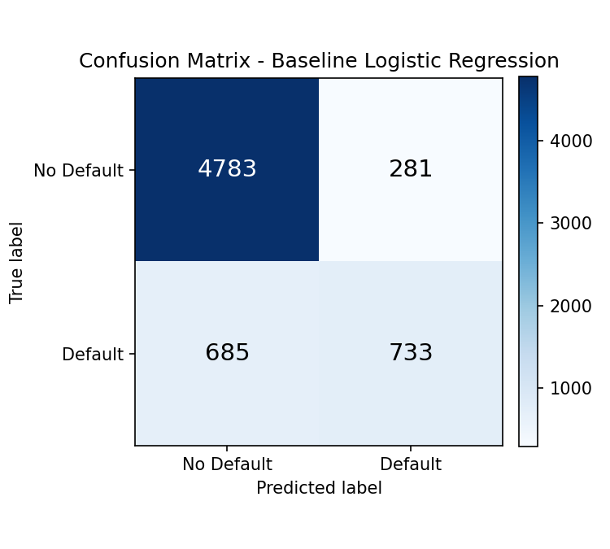
Figure 8: Matrix of baseline logistic regression.
Despite strong overall accuracy, the recall for the Default class (0.52) indicates the model correctly identified only 52% of actual defaulters, missing 685 of 1,418 in the test set.

6b. Addressing Class Imbalance — Balanced Logistic Regression
A second model was trained using class_weight='balanced', increasing the penalty for misclassifying the minority (Default) class during training. Results are shown in Table 6 and Figure 9.
Class | Precision | Recall | F1-Score | Support
0 (No Default) | 0.93 | 0.79 | 0.85 | 5,064
1 (Default) | 0.51 | 0.79 | 0.62 | 1,418
Accuracy |  |  | 0.79 | 6,482
Table 11: Classification report — balanced logistic regression.
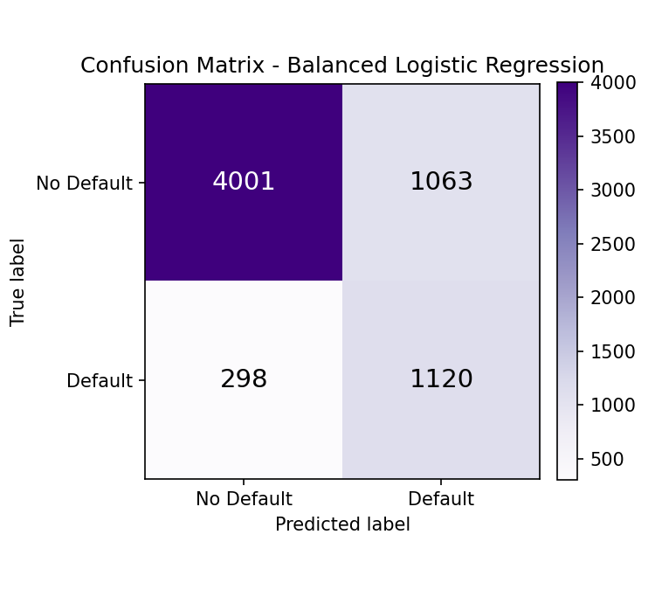
Figure 9: Matrix of balanced logistic regression

6c. Model Comparison
Metric (Class 1 - Default) | Baseline | Balanced | Change
Recall | 0.52 | 0.79 | +0.27
Precision | 0.72 | 0.51 | -0.21
F1-Score | 0.60 | 0.62 | +0.02
Overall Accuracy | 0.85 | 0.79 | -0.06
Table 12: Comparison of baseline and balanced logistic regression models.
The balanced model trades precision for a substantial gain in recall on the Default class. Although overall accuracy is lower, accuracy alone is not the most appropriate metric given the class imbalance. The choice of model depends on the relative cost of each error: a false negative (missed default) causes direct financial loss, while a false positive (unnecessary rejection) causes only a missed opportunity. Since missed defaults are typically costlier, the balanced model is recommended despite its lower headline accuracy.

7. Final Conclusion & Business Recommendations
This project analyzed a credit risk dataset of 32,581 borrower records to identify the factors most associated with loan default and build a predictive model to support lending decisions.
- Data quality: cleaning removed 165 duplicates and 7 logically-impossible rows, while retaining legitimate high-income values as a distribution tail.
- Key risk drivers: loan_percent_income (Capacity) was the strongest single indicator of default risk, followed by loan_int_rate and loan_grade (Character), directly supporting the 5C framework.
- Model performance: a baseline logistic regression achieved 85.1% accuracy but only 52% recall on defaulters. A rebalanced version improved recall to 79% at the cost of precision which is a more risk-conscious trade-off.
Recommendation: the balanced logistic regression is recommended as a screening tool to flag higher-risk applications for closer manual review, rather than as a fully automated approval system, since even the improved model misses roughly 1 in 5 actual defaulters.

